

AWS Identity and Access Management

What Is IAM?

- AWS Identity and Access Management (IAM) is a web service that helps you securely control access to AWS resources for your users.

- You use IAM to control who can use your AWS resources (authentication) and what resources they can use and in what ways (authorization).

- IAM is global to all AWS regions, creating a user account will apply to all the regions

- Benefits:

  - Central control of AWS resources

  - Consolidated AWS bill for your users

  - Ensure users access only from specified networks

  - Easily manage security credentials

  - Provides temporary user access when needed

  - Federate with SAML providers such as active directory for temporary and single sign on access

Provide roles that other AWS resources can assume

IAM Features

- IAM Features

You can grant other people permission to administer and use resources in your AWS account without having to share your password or access key.

- Granular permissions

You can grant different permissions to different people for different resources.

- Secure access to AWS resources for applications that run on Amazon EC2

You can use IAM features to securely give applications that run on EC2 instances the credentials that they need in order to access other AWS resources, like S3 buckets and RDS or DynamoDB databases

- Identity federation

You can allow users who already have passwords elsewhere—for example, in your corporate network or with an Internet identity provider—to get temporary access to your AWS account

- Free to use

AWS Identity and Access Management is a feature of your AWS account offered at no additional charge. You will be charged only for use of other AWS products by your IAM users

Accessing IAM

You can work with AWS Identity and Access Management in any of the following ways.

- AWS Management Console

The console is a browser-based interface to manage IAM and AWS resources.

- AWS Command Line Tools

You can use the AWS command line tools to issue commands at your system's
command line to perform IAM and AWS tasks.

3. AWS SDKs

AWS provides SDKs (software development kits) that consist of libraries and sample
code for various programming languages and platforms (Java, Python, Ruby, .NET,
iOS, Android, etc.).

Overview of Identity Management: Users

For greater security and organization, you can give access to your AWS account to specific users—identities that you create with custom permissions. You can further simplify access for those users by federating existing identities into AWS.

- First-Time Access Only: Your Root Account Credentials

- IAM Users

- Federating Existing Users

First-Time Access Only: Your Root Account Credentials

- When you create an AWS account, you create an account (or "root") identity, which you use to sign in to AWS.

- this combination of your email address and password is also called your root account credentials.

- When you use your root account credentials, you have complete, unrestricted access to all resources in your AWS account, including access to your billing information and the ability to change your password. This level of access is necessary when you first set up your account

- However, we recommend that you don't use root account credentials for everyday access.

IAM Users

- Instead of sharing your root account credentials with others, you can create individual IAM users within your account that correspond to users in your organization.

- IAM users are not separate accounts; they are users within your account. Each user can have its own password for access to the AWS Management Console.

Federating Existing Users

- If your users already have a way to be authenticated—for example, by signing in to your corporate network—you can federate those user identities into AWS.

- If your corporate directory is compatible with Security Assertion Markup Language 2.0 (SAML 2.0), you can configure your corporate directory to provide single-sign on (SSO) access to the AWS Management Console for your users

- If your corporate directory is not compatible with SAML 2.0, you can create an identity broker application to provide single-sign on (SSO) access to the AWS Management Console for your users

- If your corporate directory is Microsoft Active Directory, you can use AWS Directory Service to establish trust between your corporate directory and your AWS account.

Overview of Access Management: Permissions and Policies

What is the user allowed to do in my account?", often referred to as authorization. The basic tool for granting permissions in IAM is the policy.

- Policies and Users

- Policies and Groups

- Federated Users and Roles

- User-based and Resource-based Policies

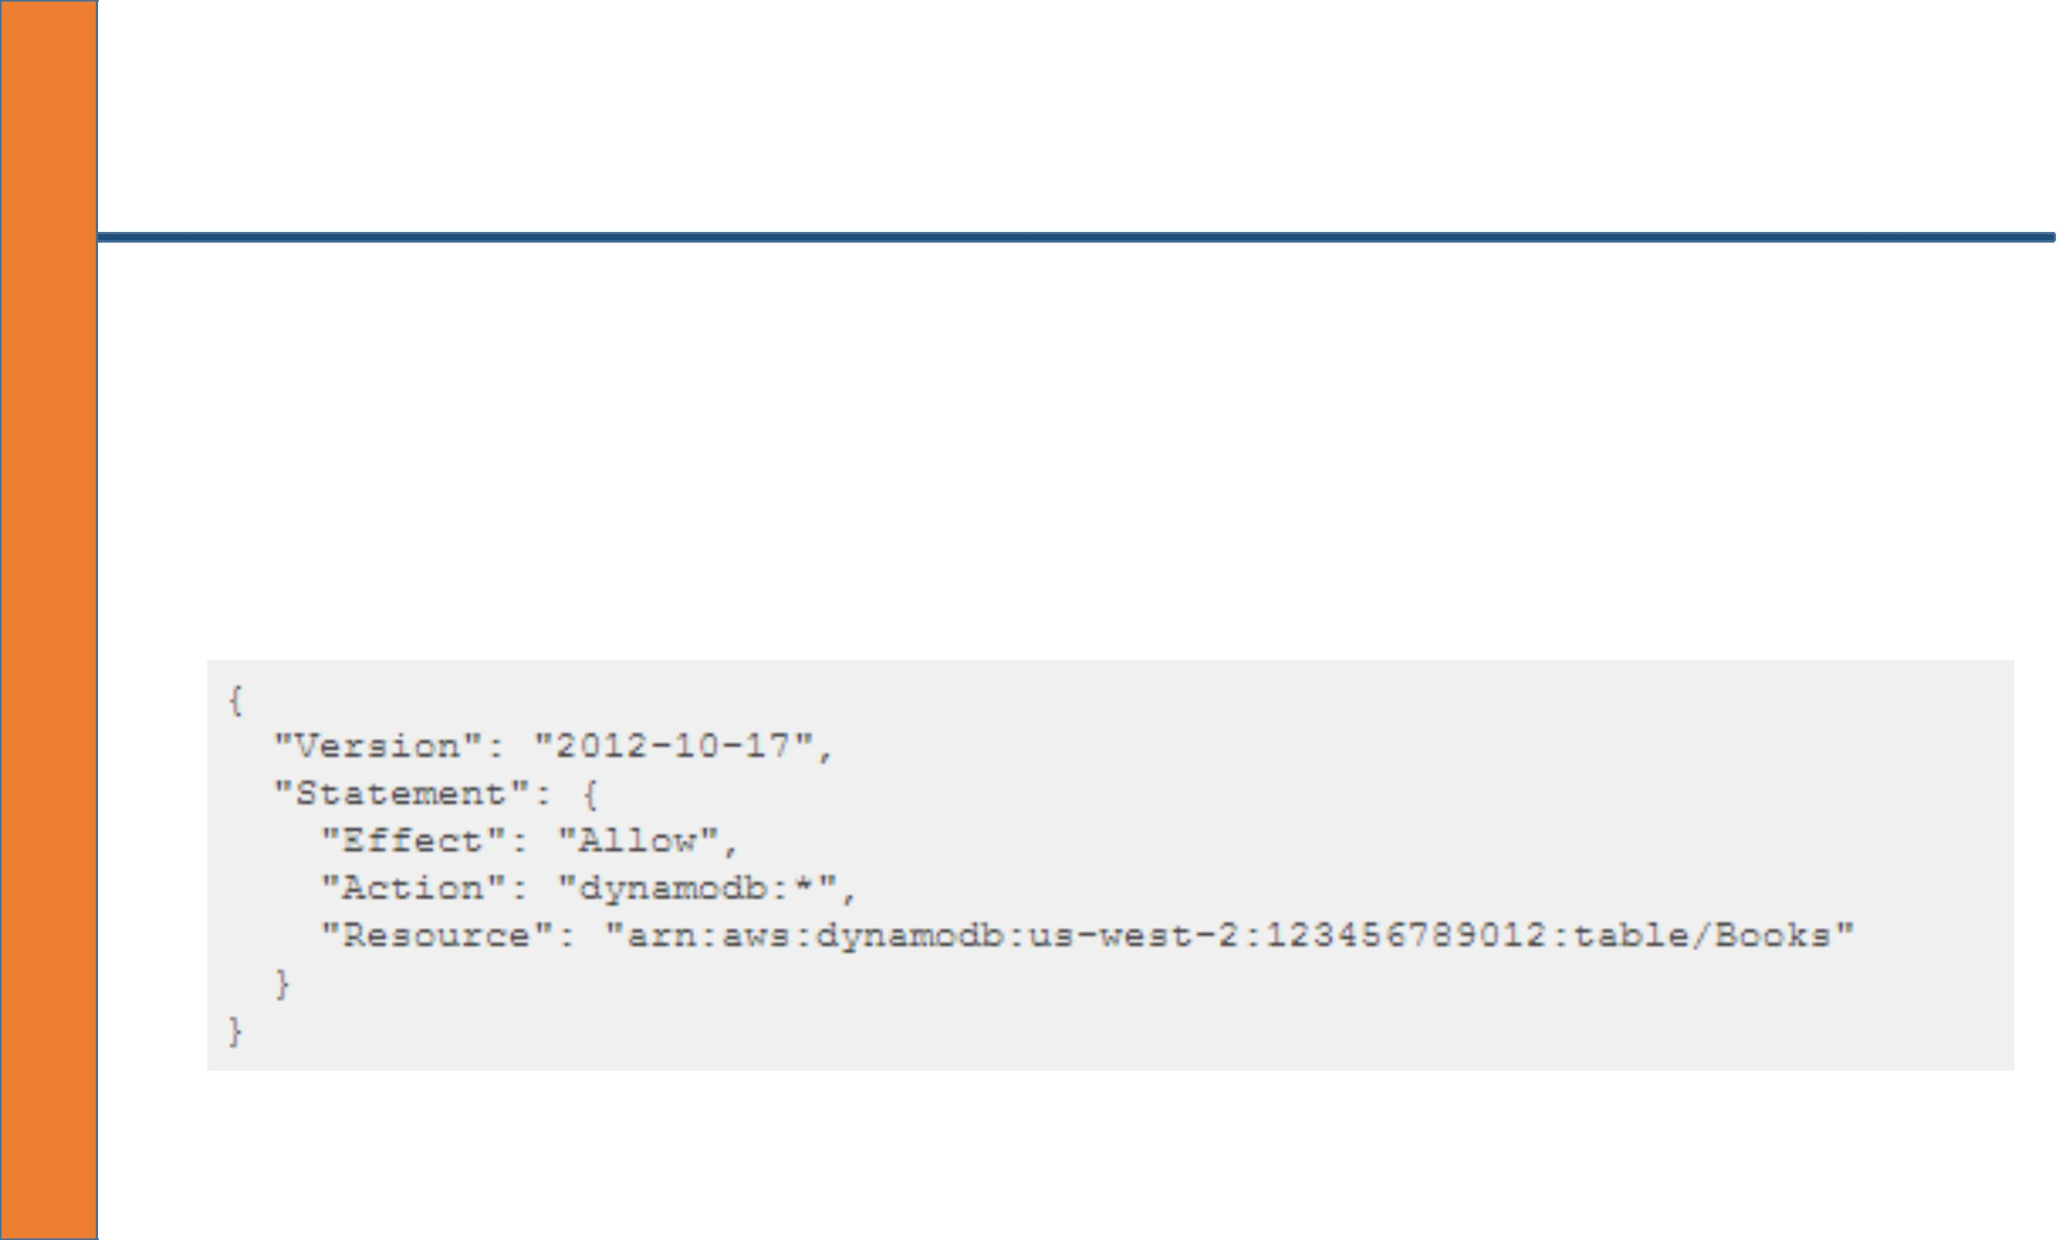
Policies and Users

- By default, users can't access anything in your account.

- You grant permissions to a user by creating a policy, which is a document that lists the actions that a user can perform and the resources that the actions can affect.

Policies and Groups

- You can organize IAM users into IAM groups and attach a policy to a group.

- In that case, individual users still have their own credentials, but all the users in a group have the permissions that are attached to the group. Use groups for easier permissions management.
Federated Users and Roles

- Federated users don't have permanent identities in your AWS account the way that IAM users do.

- To assign permissions to federated users, you can create an entity referred to as a role and define permissions for the role. When a federated user signs in to AWS, the user is associated with the role and is granted the permissions that are defined in the role.



